Data Driven Framework with Apache POI – Excel
Reading data from the Excel
We need a way to open Excel sheet and read data from it within our Selenium test script.
For this purpose, we use the Apache POI library, which allows you to read, create and edit Office-documents using Java.
How to do it…
STEP 1.
Download JAR files of Apache POI (Download poi-bin-3.15-20160924.zip)

Download Link :
http://poi.apache.org/download.html
https://www.apache.org/dyn/closer.lua/poi/release/bin/poi-bin-3.15-20160924.zip

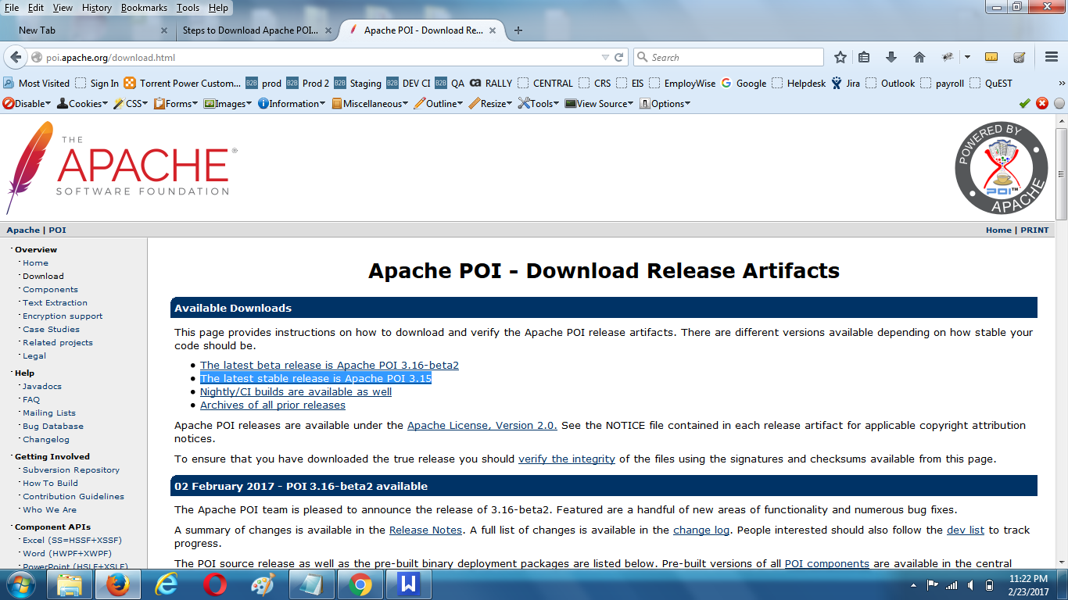

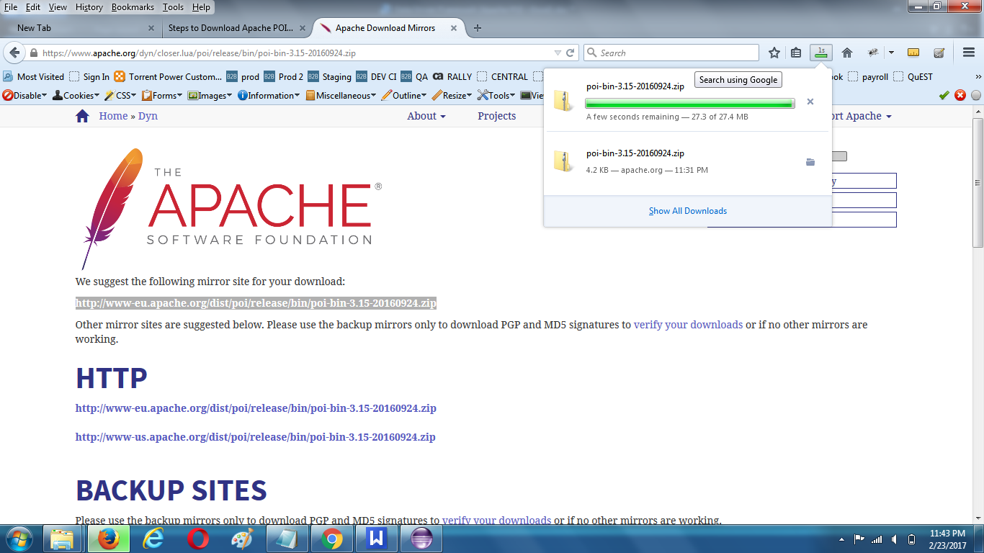

STEP 2 :
Add External Jars to your project library

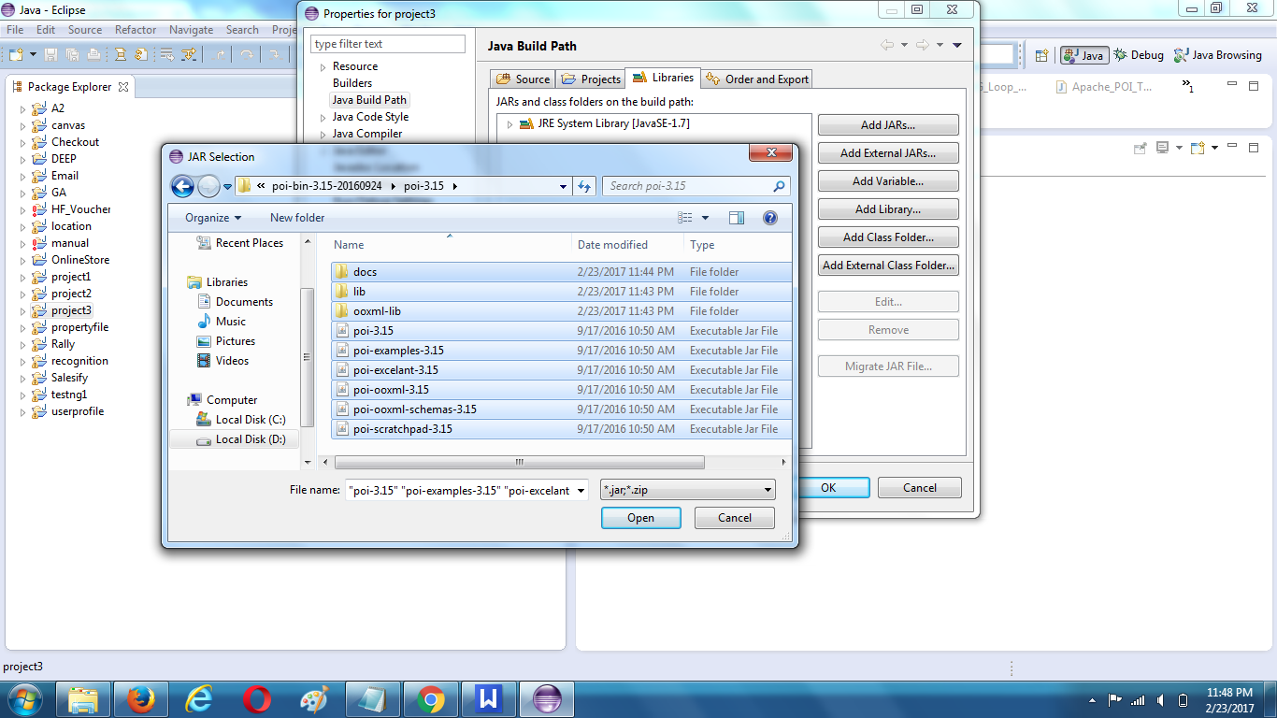

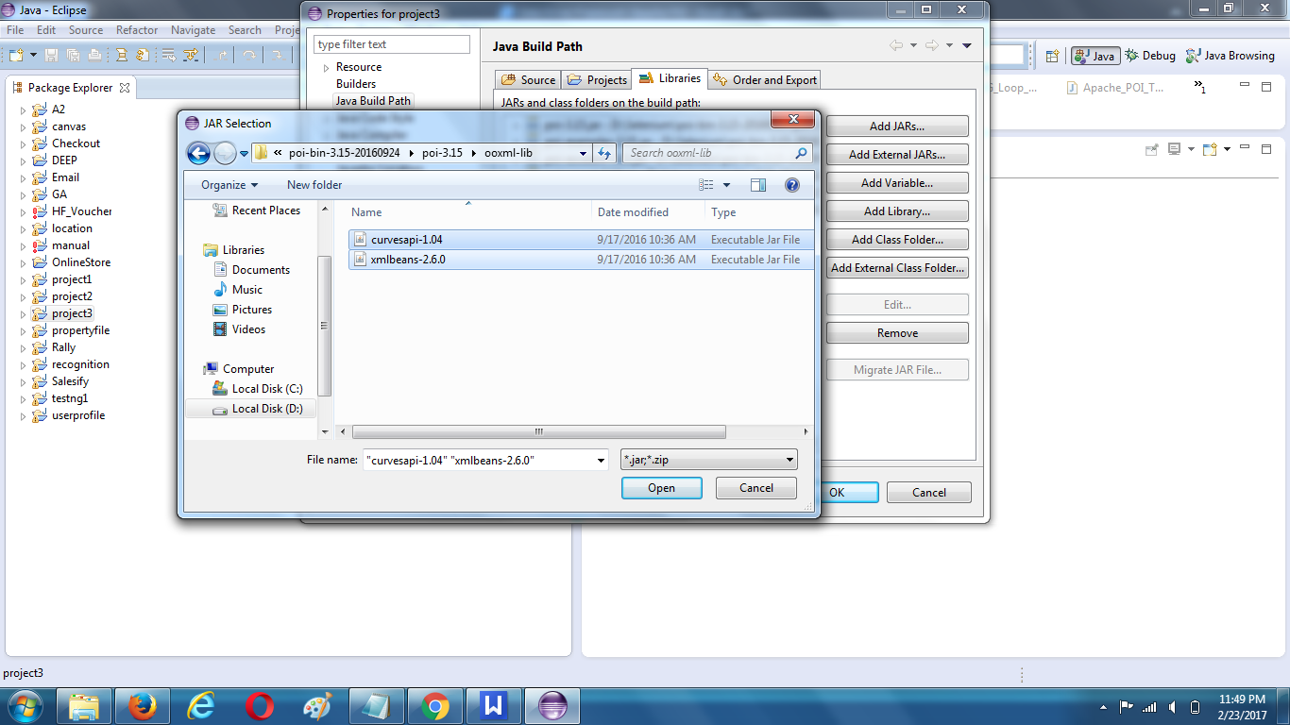

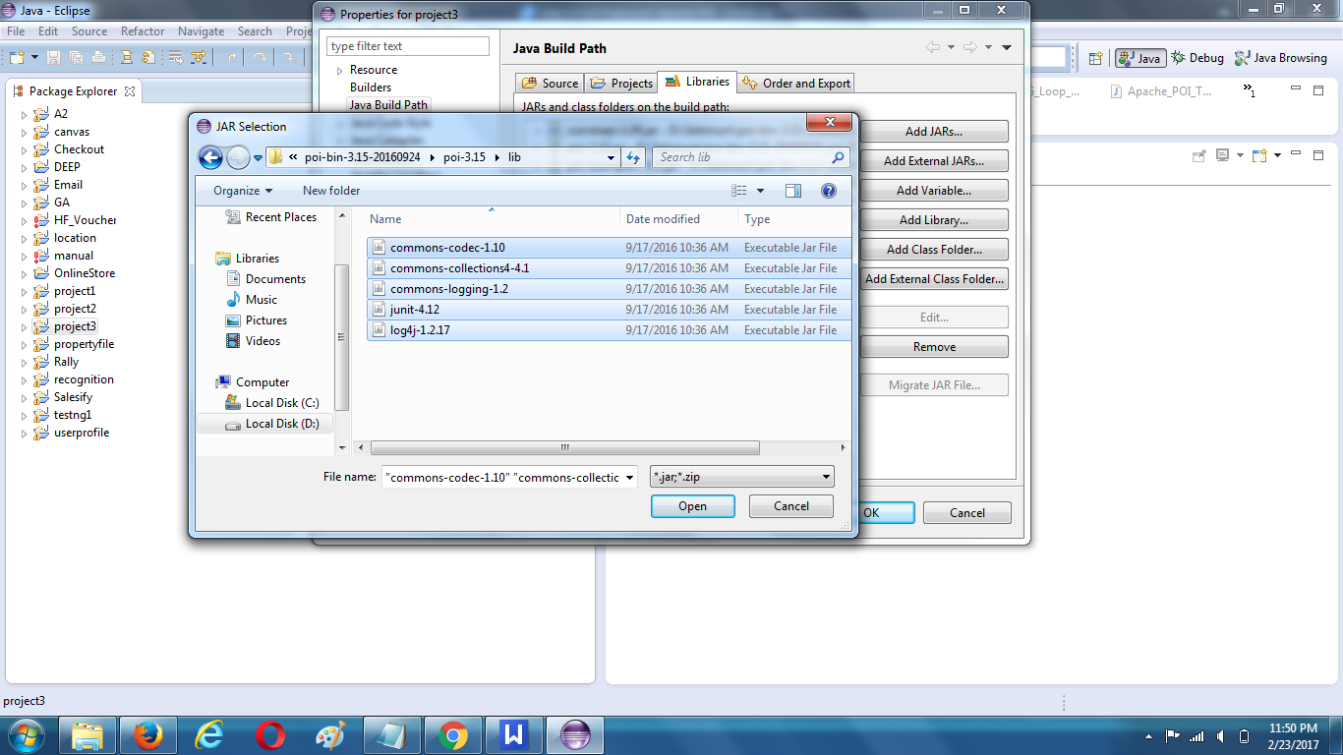

Now your project folder will look like this:
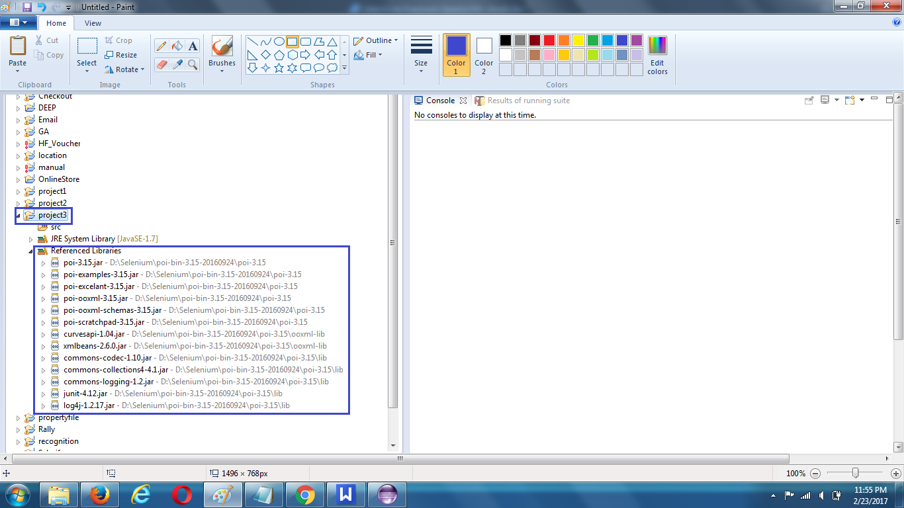

STEP 3 :

Create a package ‘testData’ for project & then Add ‘TestData.xls’ file inside it which contains test data for test execution

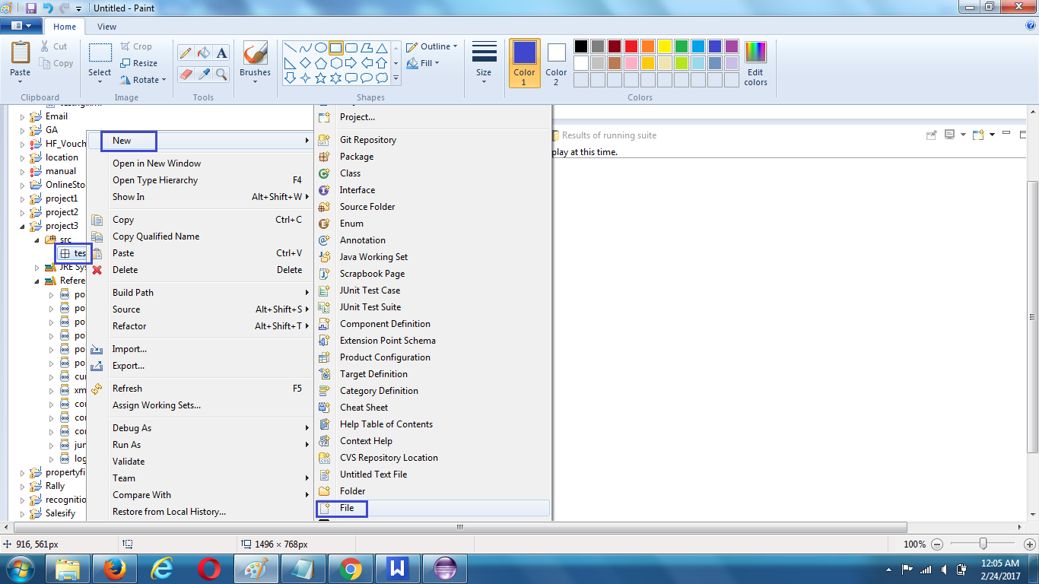

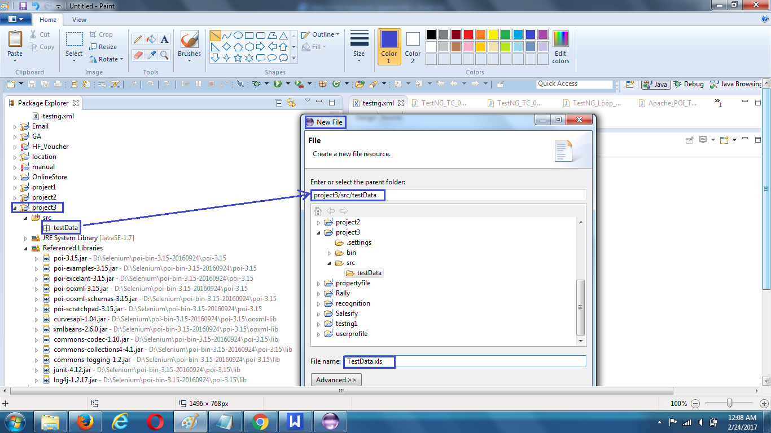

Now your project folder will look like this:
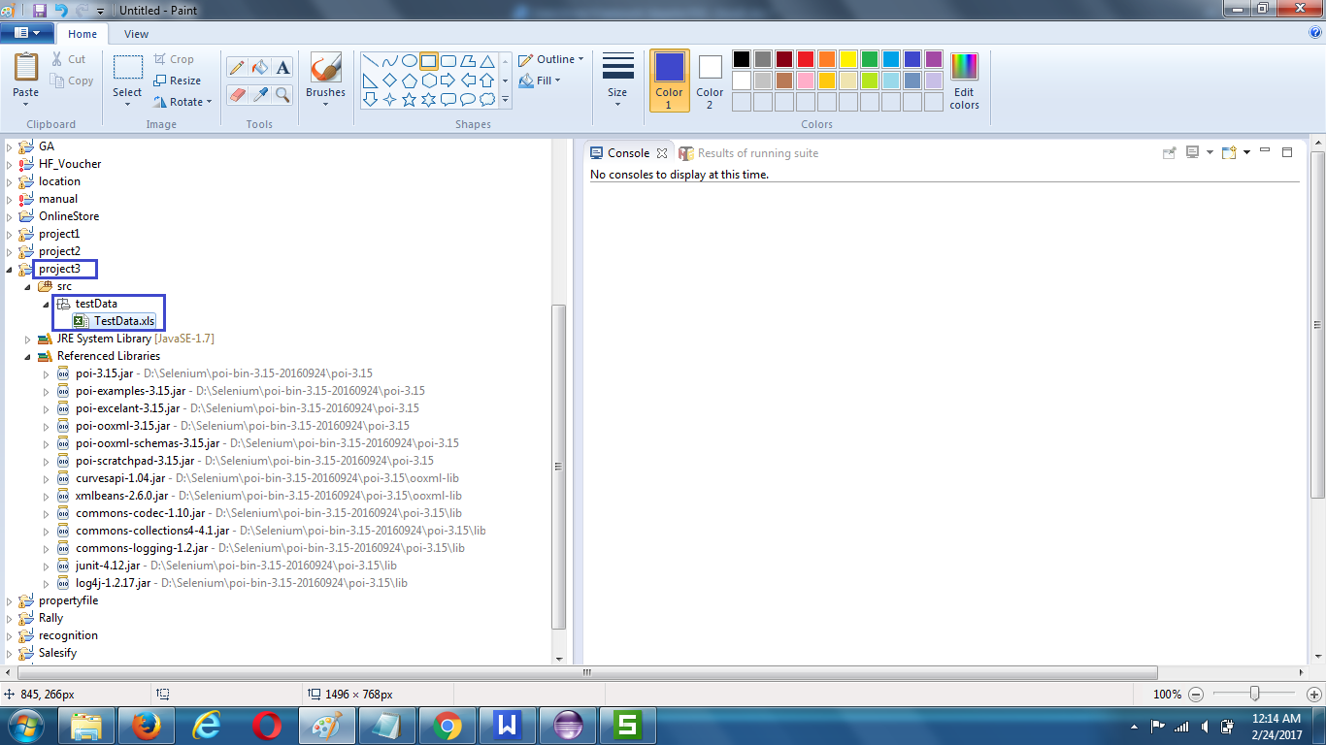

STEP 4 :
Open Excel Sheet & Write Test Data into Excel Sheet as follows & then Save :

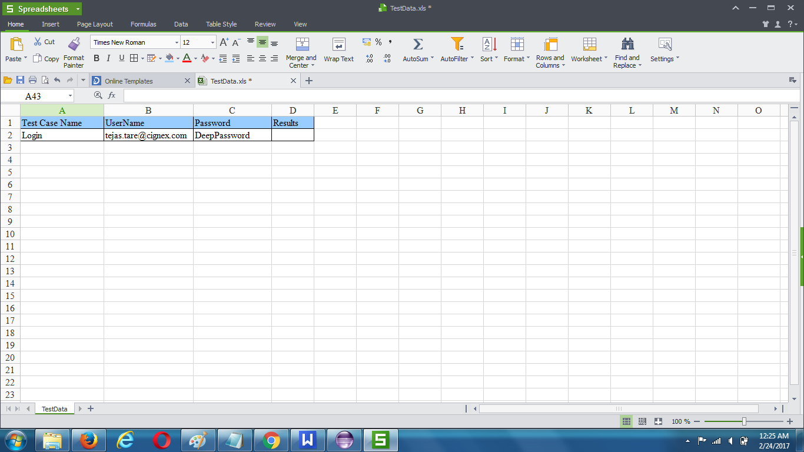

STEP 5 :

Create a package ‘utility’ for project & then create a new class ‘Constant.java’
containing following list constant variables :
URL
Path_TestData
File_TestData

Code :
package utility;

public class Constant {

public static final String URL = "http://deep.cignex.com/user/login?destination=home";

public static final String Path_TestData = "D://workspace//project3//src//testData//";

public static final String File_TestData = "TestData.xls";

}

Now your project folder will look like this:

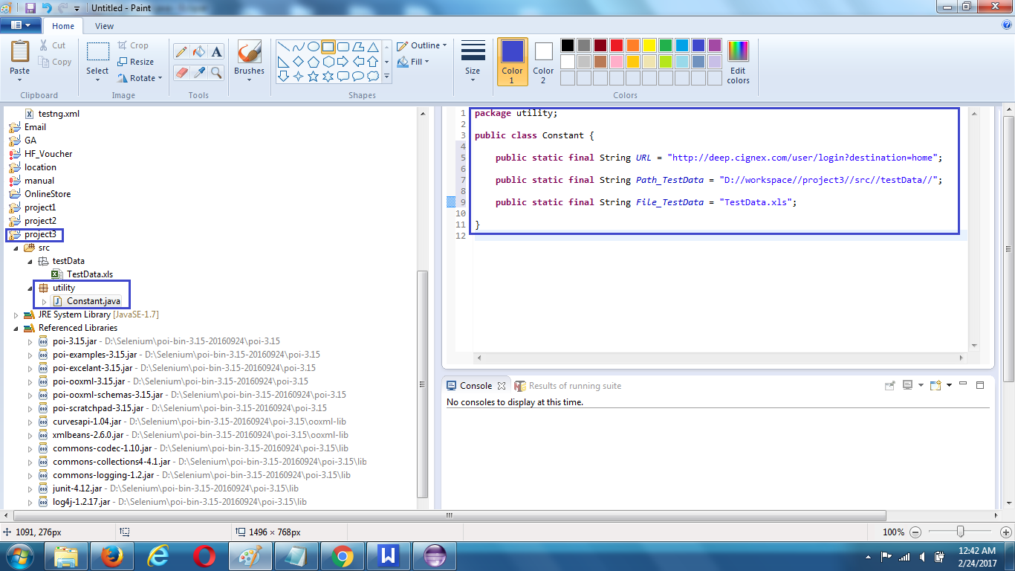

STEP 6 :

Create a package ‘utility’ for project & then create a new class ‘ExcelUtils.java’
containing the following list methods to perform Open/Read/Write operations from Excel File

public static void setExcelFile(String Path, String SheetName)
This method is to set the File path and to open the Excel file
Passing String Path and String Sheetname as Arguments

public static String getCellData(int RowNum, int ColNum)
This method is to read the test data from the Excel cell
Passing parameters as Row num and Col num

public static void setCellData(String Result, int RowNum, int ColNum)
This method is to write in the Excel cell,
Row num and Col num are the parameters

Code :

package utility;

import java.io.FileInputStream;
import java.io.FileOutputStream;

import org.apache.poi.ss.usermodel.Sheet;
import org.apache.poi.ss.usermodel.Workbook;
import org.apache.poi.ss.usermodel.WorkbookFactory;

public class ExcelUtils {

private static Sheet ExcelWSheet;

private static Workbook ExcelWBook;

private static org.apache.poi.ss.usermodel.Cell Cell;

private static org.apache.poi.ss.usermodel.Row Row;

// This method is to set the File path and to open the Excel file,
// Pass Path and Sheetname as Arguments to this method

public static void setExcelFile(String Path, String SheetName)
throws Exception {

try {

// Open the Excel file

FileInputStream ExcelFile = new FileInputStream(Path);

// Access the required test data sheet

ExcelWBook = WorkbookFactory.create(ExcelFile);

ExcelWSheet = ExcelWBook.getSheet(SheetName);

} catch (Exception e) {

throw (e);

}

}

// This method is to read the test data from the Excel cell,
// In this we are passing parameters as Row num and Col num

public static String getCellData(int RowNum, int ColNum) throws Exception {

try {

Cell = ExcelWSheet.getRow(RowNum).getCell(ColNum);

String CellData = Cell.getStringCellValue();

return CellData;

} catch (Exception e) {

return "";

}

}

// This method is to write in the Excel cell,
// Row num and Col num are the parameters

public static void setCellData(String Result, int RowNum, int ColNum)
throws Exception {

try {

Row = ExcelWSheet.getRow(RowNum);

Cell = Row.getCell(ColNum,
org.apache.poi.ss.usermodel.Row.RETURN_BLANK_AS_NULL);

if (Cell == null) {

Cell = Row.createCell(ColNum);

Cell.setCellValue(Result);

} else {

Cell.setCellValue(Result);

}

// Constant variables Test Data path and Test Data file name

FileOutputStream fileOut = new FileOutputStream(
Constant.Path_TestData + Constant.File_TestData);

ExcelWBook.write(fileOut);

fileOut.flush();

fileOut.close();

} catch (Exception e) {

throw (e);

}

}

}

Now your project folder will look like this:
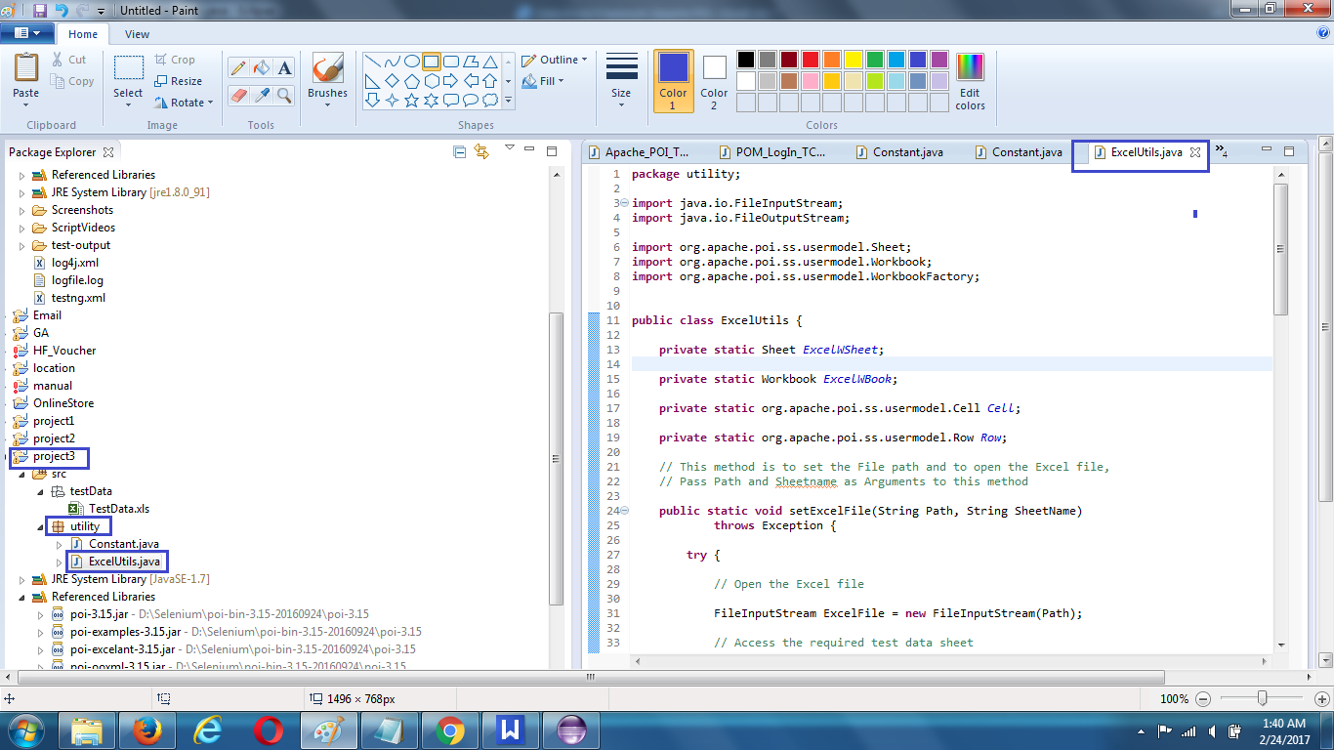

STEP 6 :

Set Modular Driven Framework
In most of the web application, we will have some set of actions which are executed repeatedly.

So Rather than writing those actions again and again in our test, we can club those actions in to a method and then call that method in our test script.

Modularity avoids duplication of code. In future if there is any change in the set of action, then we just need to make changes in modular method script only.

How to do it..
Look for repeated functionality in your application for example the ‘login’ functionality.
We can wrap this functionality in a method

Create a package ‘appModule’ for project & then create a new class ‘LogIn_Action.java’
containing all the required Steps for Login

Code :
package appModules;

import utility.*;
//import pageObjects.*;

import org.openqa.selenium.By;
import org.openqa.selenium.WebDriver;

// Now this method does not need any arguments

public class LogIn_Action {

public static void Execute(WebDriver driver) throws Exception {

// Data driven approach with Apache POI Excel
// This is to get the values from Excel sheet,
// passing parameters (Rownum &amp; Col num)to getCellData method

String sUserName = ExcelUtils.getCellData(1, 1);

String sPassword = ExcelUtils.getCellData(1, 2);

//Step to Enter User Name

// Data driven approach with Apache POI Excel
driver.findElement(By.xpath("//input[@id='edit-name']")).sendKeys(sUserName);

// Step to Enter Password

// Data driven approach with Apache POI Excel driver.findElement(By.xpath("//input[@type='password']")).sendKeys(sPassword);

//Step to Click LogIn Button

driver.findElement(By.xpath("//button[@value='LOGIN']")).click();
}

}

Now your project folder will look like this:

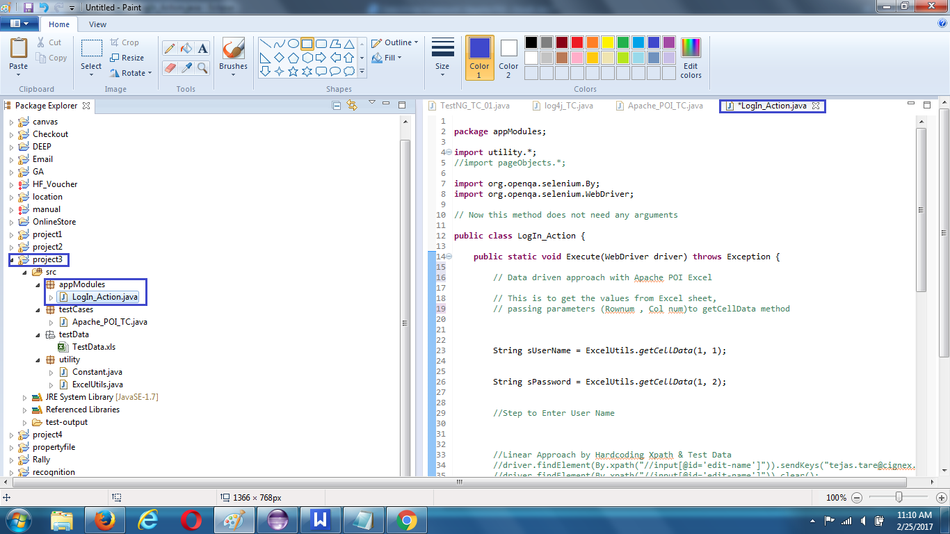

STEP 7 :
Set Page Object Model | POM
Advantage of POM :
1. We can easily manage and maintain Locators, xpaths in our script
2. we can avoid duplication of code, locators, xpaths in our script

How to do it..
Create a package ‘pageObject’ for project & then create a new class ‘LogIn_Page.java’
Now create a Static Method for each Element (Object) of the Login Page.
Ex-
public static WebElement txtbx_UserName(WebDriver driver){
element = driver.findElement(By.id("user"));
return element;
}

Each method will have an Argument (driver) and a Return value (element).
Driver is being passed as an Argument so that Selenium is able to locate the element on the browser (driver).
Element is returned, so that an Action can be performed on it.
Method is declared as Public Static, so that it can be called in any other method

APACHE POI
Field | String Variable  for storing test data | Getting value from  excel by cell location
User Name | sUserName | ExcelUtils.getCellData(1, 1);
Password | sPassword | ExcelUtils.getCellData(1, 2);

Page Object Model | POM
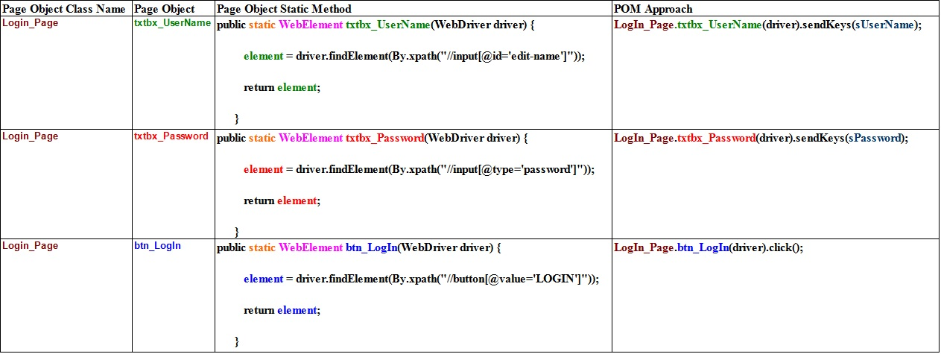
Code:
package pageObjects;

import org.openqa.selenium.*;

public class LogIn_Page {

private static WebElement element = null;

public static WebElement txtbx_UserName(WebDriver driver) {

element = driver.findElement(By.xpath("//input[@id='edit-name']"));

return element;

}

public static WebElement txtbx_Password(WebDriver driver) {

element = driver.findElement(By.xpath("//input[@type='password']"));

return element;

}

public static WebElement btn_LogIn(WebDriver driver) {

element = driver.findElement(By.xpath("//button[@value='LOGIN']"));

return element;

}

}

Now your project folder will look like this:
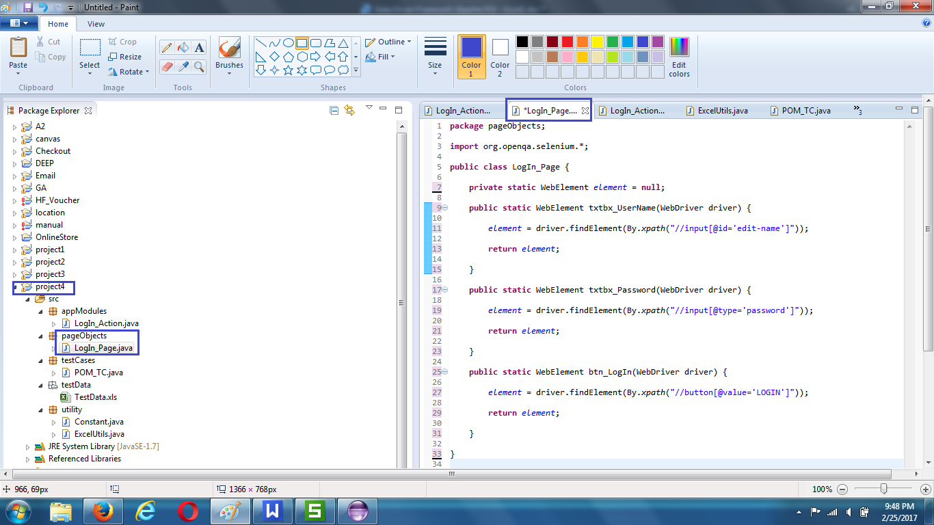

STEP 8 :
Modify Login_Action of appModule as per POM Approach
Note - Import pageObjects
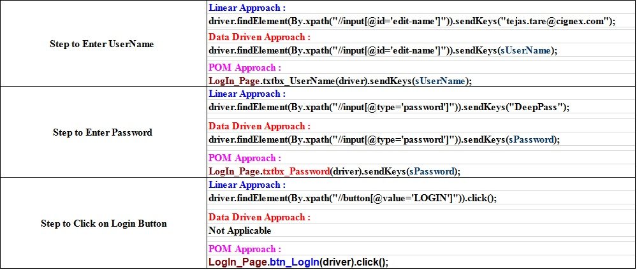

Code :
package appModules;

import utility.*;
import pageObjects.*;

//import org.openqa.selenium.By;
import org.openqa.selenium.WebDriver;

// Now this method does not need any arguments

public class LogIn_Action {

public static void Execute(WebDriver driver) throws Exception {

// This is to get the values from Excel sheet,
// passing parameters (Rownum &amp; Col num)to getCellData method

String sUserName = ExcelUtils.getCellData(1, 1);

String sPassword = ExcelUtils.getCellData(1, 2);

//Step to Enter User Name

LogIn_Page.txtbx_UserName(driver).sendKeys(sUserName);

// Step to Enter Password

LogIn_Page.txtbx_Password(driver).sendKeys(sPassword);

//Step to Click LogIn Button

LogIn_Page.btn_LogIn(driver).click();

}

}

STEP 9
Create a package ‘testCases’ for project & then create a new class ‘Apache_POI_TC.java’

Data Driven Approach
In this we will read the values from the Excel sheet to use them as the test data and
Then write the test result in the Excel.

Function Driven Approach
Also we will call a function inside @test annotation, which we have created for login action

Code :
package testCases;

import org.openqa.selenium.WebDriver;
import org.openqa.selenium.firefox.FirefoxDriver;

import appModules.*;

import org.testng.annotations.Test;
import org.testng.annotations.BeforeMethod;
import org.testng.annotations.AfterMethod;

import utility.*;

public class Apache_POI_TC {

public static WebDriver driver;

@Test
public void main() throws Throwable {
// Functiona driven approach
LogIn_Action.Execute(driver);
}

@BeforeMethod
public void beforeMethod() throws Exception {
ExcelUtils.setExcelFile(
Constant.Path_TestData + Constant.File_TestData, "TestData");
//Imp Note :- TestData is sheet name from excel

driver = new FirefoxDriver();
driver.get(Constant.URL);
driver.manage().window().maximize();
}

@AfterMethod
public void afterMethod() throws Exception {
// Close the driver
driver.quit();
// Writing result to excel sheet
ExcelUtils.setCellData("Pass", 1, 3);

}

}
Now your project folder will look like this
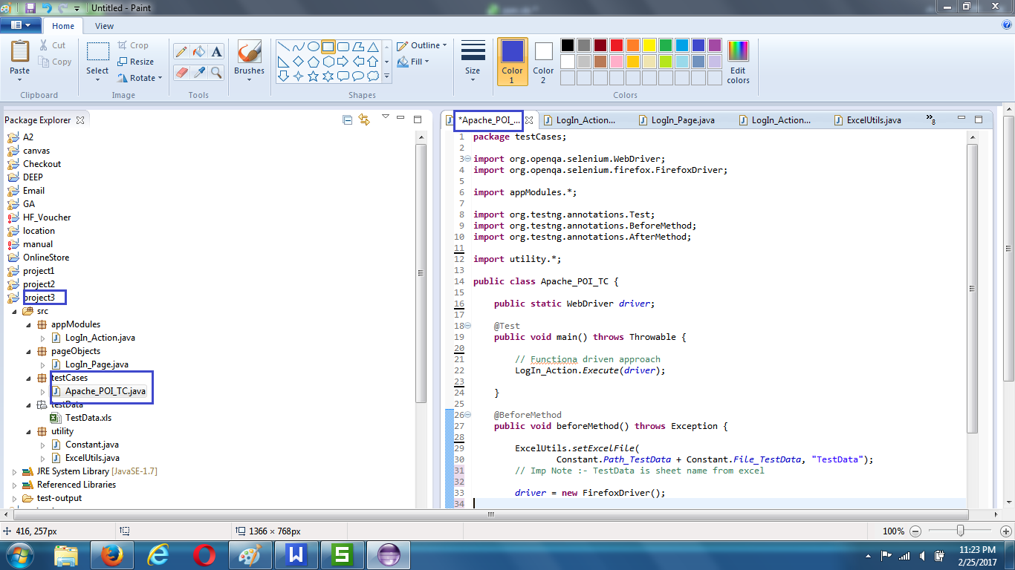

STEP 10 :
TC Execution, Check Test NG Results & Test NG Reports, Check Result in Excel Sheet

Run Apache_POI_TC as TestNG

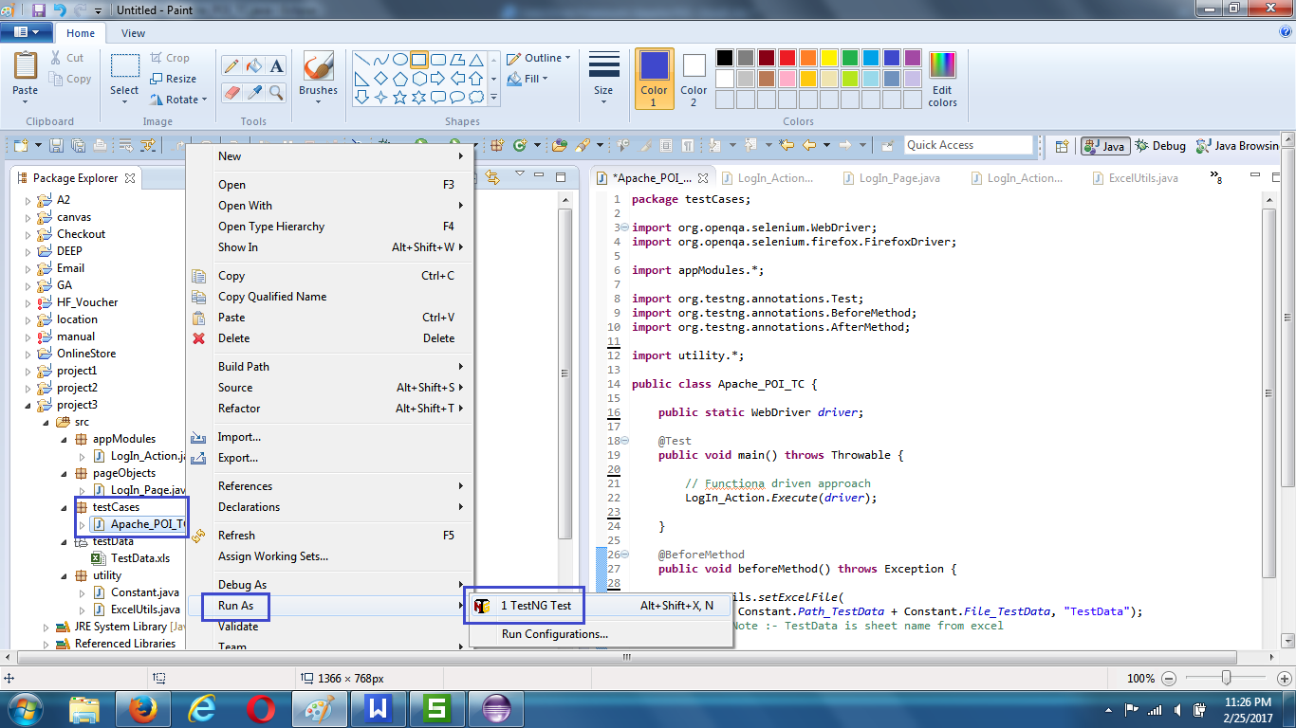

Check TestNG Results

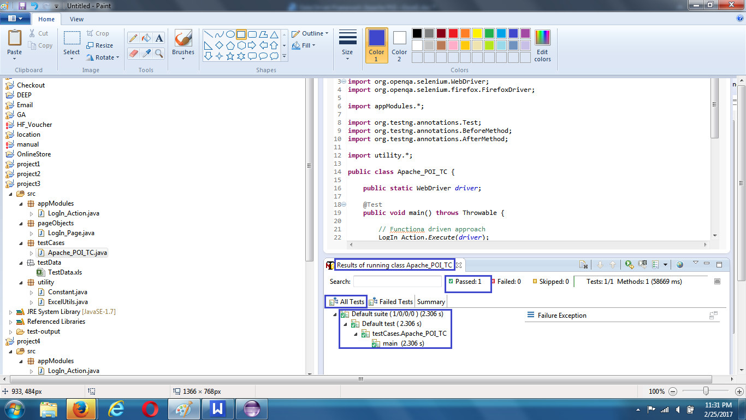

Check Test NG Reports

Refresh Project , Expand Out -Put Folder , click on Index.html

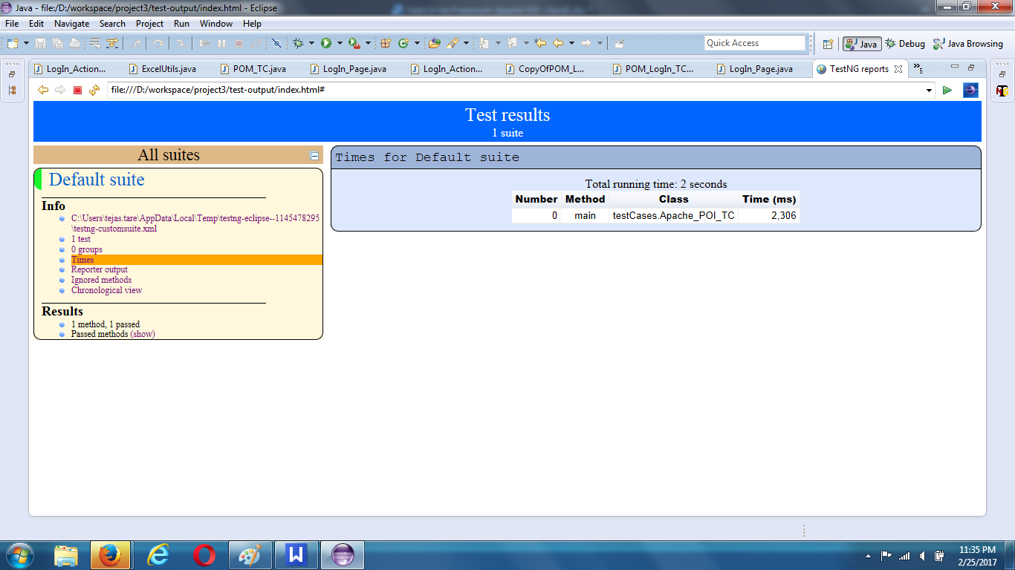

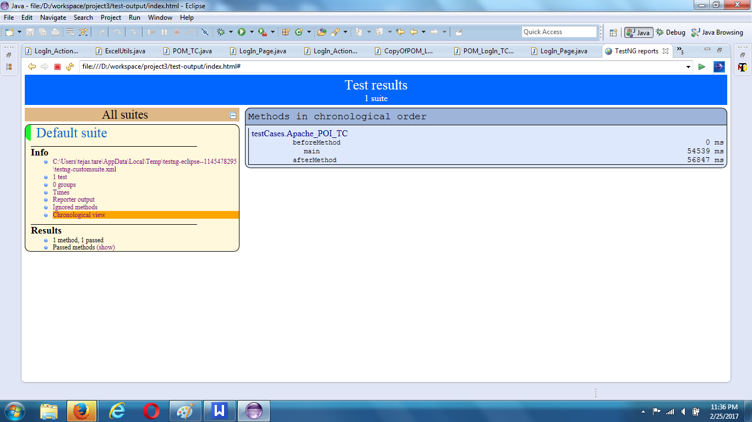

Check Result in Excel Sheet - Result updated as Pass in Excel

